Dev Handoff Notes
Team 15 — Login Restyle & Team Page

Project | Telstra-Network API (NaaP) Innovation — COSC2408 Programming Project 1
Team | Team 15
Prepared by | Abin Siju — UX Designer
Prepared for | Tom Lynch & Varinder Pal Singh Bhatti — Developers
Date | 11 August 2026
Status | Ready for Dev — pending final BA/PM handoff confirmation

1. Overview
This restyles the existing login page and adds a new authenticated Team 15 page. Auth logic, validation and session handling are unchanged — this is a visual/UX handoff only, covering layout, styling, copy, states and edge cases.

2. Reference Links
- Figma (wireframes + mockup): https://www.figma.com/design/do4fr8TAGOu7HLsTDoIKkz
- Interactive prototype: team15-prototype.html (in repo — open directly in a browser, no build step needed)
- BA Requirements Specification: 10 August 2026, Aditya Barot (linked from the Planner UX card)
- UX Design Brief: Team15_UX_Design_Brief.docx (repo, same folder)

3. Screens
Wireframe (structure/layout pass) and final mockup (styled to match the live boilerplate exactly) — both exported from the Figma file linked above, which stays the live source of truth for Dev Mode inspection.
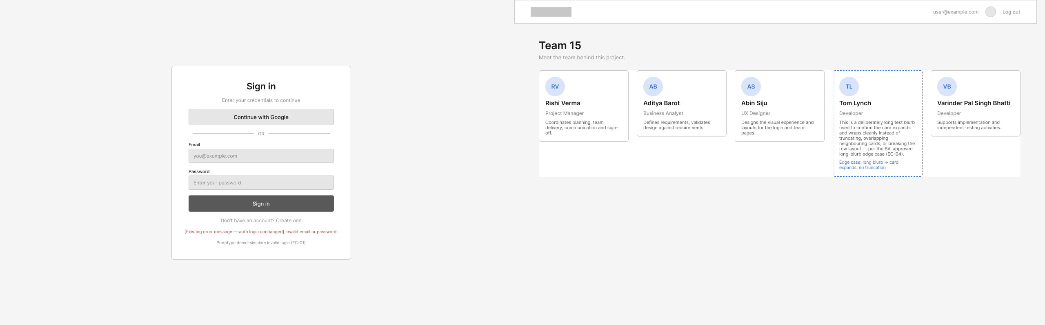
Fig. 1 — Lo-fi wireframe: Sign in + Team 15 (structure and edge cases, greyscale).
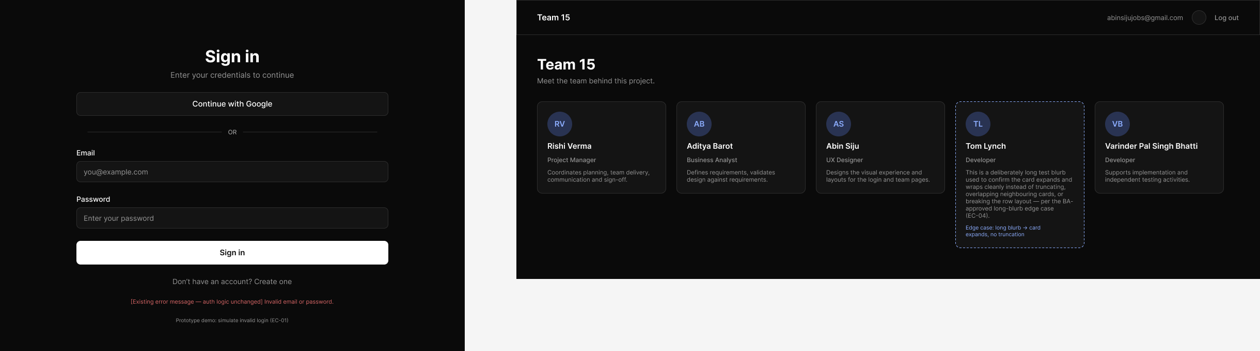
Fig. 2 — Final mockup: Sign in + Team 15, styled to match the live boilerplate exactly. This is the version to build from.

4. Colour Palette
Matches the existing live boilerplate — this is a restyle, not a rebrand, so no new brand colours were introduced.
 | Token | Hex | Usage
 | Background | #0A0A0A | Page background
 | Surface | #141414 | Cards, input fields, secondary buttons
 | Border | #2E2E2E | Card/input borders, dividers
 | Text Primary | #FFFFFF | Headings, primary body text (on dark backgrounds)
 | Button Text (on white) | #0D0D0D | Text colour for the white ‘Sign in’ submit button — not Text Primary
 | Text Secondary | #949494 | Labels, placeholders, helper/meta text
 | Accent BG | #29334F | Initials-avatar background
 | Accent | #8CADFF | Initials-avatar text, edge-case annotation text/outline
 | Error | #D96666 | Validation/error message text (existing logic, styling only)

5. Typography
- Font family: system sans-serif stack (-apple-system, Segoe UI, Roboto, Helvetica, Arial) — matches what's rendering in the live app. Please confirm against the actual codebase font-family / Tailwind config and swap this note for the real value.
- Headings: 22–28px, semi-bold/bold
- Body / labels: 12–15px, regular/medium
- Meta / helper text: 11–12px, regular, Text Secondary colour

6. Component Notes
- Inputs & buttons: 8px border-radius, 1px Border-colour stroke, Surface background.
- Primary button (Sign in): white background, dark text, full width of the form.
- Google button: Surface background, Border stroke, full width, placed above the OR divider.
- Cards (team page): 10px border-radius, Surface background, Border stroke, 18–20px padding, fixed width ~230px, auto height (do not fix height — see long-blurb edge case).
- Avatar: 48px circle, Accent BG background, Accent-coloured initials text, centred.

7. Login Screen — Exact Copy & Fields
- Heading: “Sign in”
- Subtitle: “Enter your credentials to continue”
- Button: “Continue with Google”
- Divider: “OR”
- Field 1 — label “Email”, placeholder “you@example.com”
- Field 2 — label “Password”, placeholder “Enter your password”
- Submit button: “Sign in”
- Bottom link: “Don’t have an account? Create one”
- No forgot-password link on this screen (confirmed against the live page — do not add one).

8. Team Page — Content
- Topbar: app logo/mark (left), user email + Log out (right) — matches the existing dashboard shell pattern.
- Heading: “Team 15”, subtitle “Meet the team behind this project.”
- 5 member cards — Rishi Verma (Project Manager), Aditya Barot (Business Analyst), Abin Siju (UX Designer), Tom Lynch (Developer), Varinder Pal Singh Bhatti (Developer) — copy as shown in the Figma file / prototype.

9. Edge Cases (BA-approved, 10 Aug)
- EC-03 — Missing photo: show the initials-avatar treatment (Accent BG circle + 2-letter initials) in place of the image — never a broken-image icon or empty space. Since real photos aren't supplied for this sprint, all 5 cards currently use this state by default.
- EC-04 — Long blurb: let the card grow vertically and wrap the text — do not truncate, do not let it overlap neighbouring cards or break the row. Demonstrated on the Tom Lynch card in the prototype.
- EC-01 — Invalid login: existing validation/error behaviour is unchanged — only the visual style of the error text should change (Error colour token). Demonstrated via the “simulate invalid login” link in the prototype.
- EC-02 — Direct team-page access without login: no visual spec needed — this is existing auth/session logic (redirect to login), out of scope for this restyle.

10. Accessibility Notes
- Focus order: Google button → Email → Password → Sign in → Create-one link (login); logo → user menu → Log out → each card in order (team page).
- Initials avatar should have an aria-label / alt text equivalent to “Photo not available for {name}” rather than being announced as decorative.
- Text/background contrast: all token pairs above meet WCAG AA at the sizes specified — please re-check if any text size is reduced from what's specced.

11. Out of Scope — Please Do Not Change
- Auth logic, validation rules, session handling, existing error behaviour.
- Any new login fields, auth methods or account-management functionality.
- Public/unauthenticated access to the team page.

12. Open Items
- Confirm actual font-family from the codebase and update Section 5.
- Confirm target sign-off date now that mockups are complete.

